EXP NO:5

Conduct task analysis for an app (e.g., online shopping) and document user flows. Create corresponding wireframes using Lucid chart

Online Shopping App

To create a flow for an online shopping platform that allows users to browse products, check availability, and make purchases in a structured and user-friendly manner.

Step 1: Assigning Tasks
Main user goals in the app:
- Access the homepage
- Log in to their account
- Browse categories
- View product availability
- Add product to cart
- Proceed with shipping & payment
- Complete checkout

Step 2: Document User Flows
1. Login Flow
Home Page → Scroll Down
Tap Login
Enter details → Redirect to Score Screen
From here, users can either:
Go to Contact Support
Start browsing via Shop Items
2. Product Browsing Flow
From Score Screen → Tap Select a Category
View results on Category Page
System cross-checks with Inventory
If product is not available → Show “Product Not Available”
If available → Show Product Image Slideshow
3. Purchase Flow
From slideshow → Proceed to Shipping
Then go to Payment
Complete process via Checkout

Step 3: Lucidchart User Flow Creation
Preparation:

- Log in to Lucidchart
- Create a blank document
Flowchart Design:
Use:
Rectangles → Actions (e.g., Login, Payment)
Diamonds → Decisions (e.g., Product Available?)
Cylinders → Databases (e.g., Inventory)
Arrows → Transitions between steps

Flow Includes:

Home → Login → Browse → Inventory Check
Slideshow → Shipping → Payment → Checkout

This flow makes the user journey smooth and logical:
- users always know the next step.
- If a product isn’t available, they are clearly informed.
- The checkout process is simple and straightforward.
- Support is accessible directly from login.

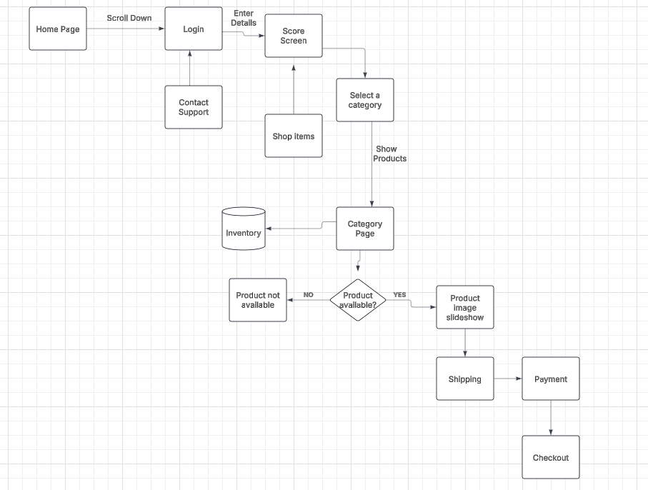

Lucidchart link https://lucid.app/lucidchart/ba89fa28-6569-403f-9bc1-675de37fc7f3/edit?viewport_loc=-854%2C-129%2C3322%2C1543%2C0_0&invitationId=inv_0374d657-d680-4296-ac6f-364ebae3a4f9

- Home Page
The user lands on the home page of the shopping website.
- Scroll Down to Login
Users can scroll to find the login option and access theiraccount.
- Login / Signup
They enter their credentials (email, password, etc.) to log in or sign up.
- Score Screen
After login, users are directed to a score screen
- Shop Items / Contact Support
From this screen, users can:
Begin browsing items by choosing to "shop items"
Or if they have any issues, click on "contact support"
- Select a Category
Users pick a category (e.g., electronics, fashion, groceries).
- View Category Page
The app displays the selected category's product listings.
- Inventory Check
Behind the scenes, the system checks the inventory database to confirm if items are available.
- Decision: Is Product Available?
If YES → User is shown a Product Image Slideshow
If NO → Message is shown: Product not available
- . Shipping
Users enter shipping information and choose delivery options.
11 . Payment
They enter payment details (card, UPI, etc.)
12. Checkout
Once payment is confirmed, the checkout process is complete and order is placed.
The online shopping app flow ensures a smooth and intuitive user experience from login to checkout. It handles product availability smartly using inventory checks and provides clear feedback if items are unavailable. Each step is logically connected, minimizing user confusion. The inclusion of support access and a visual product display enhances user satisfaction and engagement.

